FIT3179 Week 9 Homework Report
Name: Eric Wong
Student ID: 32500661
Studio: Thursday 10-12pm
Tutor Name: Ayden Zhou
Link to map:

Screen capture of map:
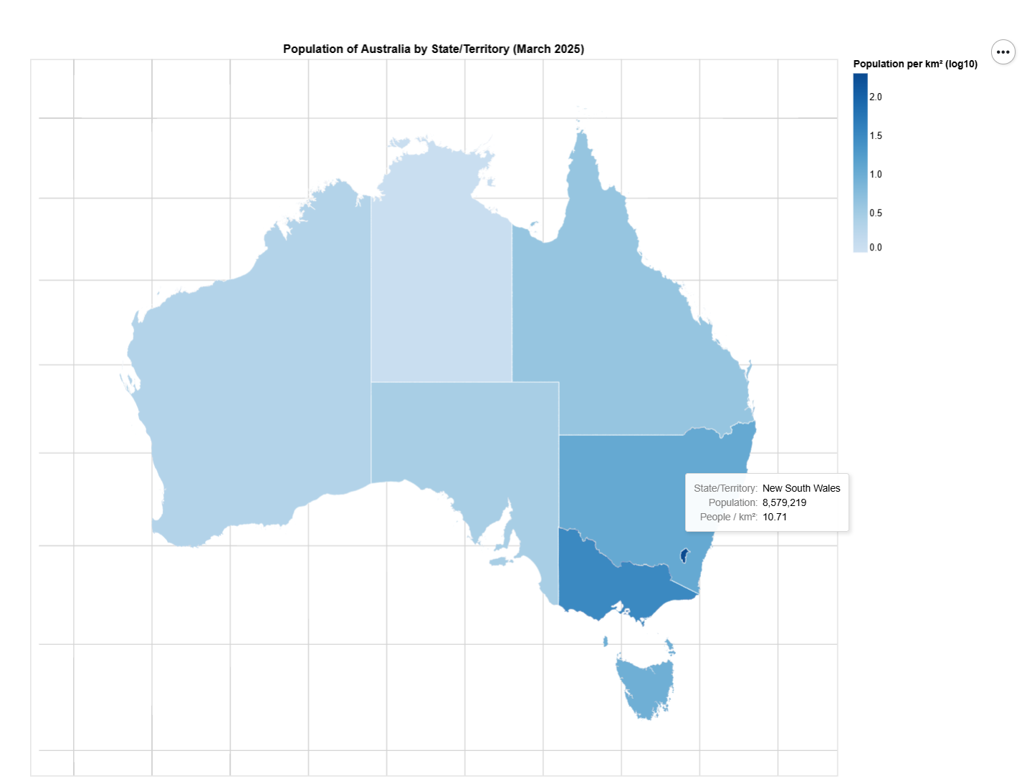
- The domain of your visualisation
  - Australia income and wealth distribution, however population will be used to compare and contrast the income across different states/territories.
- The visualised dataset (attribute types, source and author, etc.)
  - Population: quantitative; States/territories: nominal.
  - Source: https://www.abs.gov.au/statistics/people/population/national-state-and-territory-population/latest-release
- Data transformation that you applied (if any), such as normalisation by area or population.
  - Normalised population data to be population per km².
- A justification for the type of map idiom used. For example, explain why you chose to create a proportional symbol map instead of a choropleth map or a dot map.

